SIMATS ENGINEERING (SAVEETHA SCHOOL OF ENGINEERING)

Department of Computer Science and Engineering

CO1 ASSESSMENT TOOL 1 – Case Study Analysis

Course Code: | CSA10 / CSA1024 | Course Title: | Software Engineering
CO Assessed: | CO1 | Assessment: | Assessment Tool 1 – Case Study Analysis
Weightage: | 20% | Total Marks: | 25
CO1 Statement: | Apply advanced methodologies and agile project management techniques to manage software projects effectively
Student Name: | Balu S | Reg. No.: | 192572015
Date: | 11/10/2026 | Duration: | 60 minutes
Code of Conduct
I Balu S(192572015) certify that this submission is my original work and that I have adhered to the guidelines specified for this assessment. I understand that any violation of academic integrity rules will result in disciplinary action.
Signature of the Student:
Annexure A – Case Study Analysis

Instructions to Students:
Each student will be allotted one problem statement. Analyze the assigned problem systematically by following the steps given below. Your report should demonstrate your understanding of software engineering concepts and your ability to design an appropriate software solution.
Based on your allotted problem statement, prepare a report by answering the following questions:

Understand the Problem Statement
  - Explain the problem in your own words.
  - Identify the objectives of the proposed system.
  - State the scope of the problem.

Identify Key Stakeholders and Challenges
  - Identify all the stakeholders involved in the system.
  - Explain the roles and responsibilities of each stakeholder.
  - Discuss the major challenges and issues faced by the stakeholders.

Analyze the Current Approach
  - Describe the existing system or current process.
  - Identify its strengths and limitations.
  - Analyze the problems or gaps that need to be addressed.

Propose a Suitable Solution Using Software Engineering Principles
  - Design a software-based solution for the given problem.
  - Describe the major functional modules of the proposed system.
  - Identify the functional and non-functional requirements.
  - Explain how software engineering principles such as modularity, scalability, maintainability, reliability, usability, and security are incorporated into your solution.

Justify the Chosen Methodology/Framework
  - Select an appropriate Software Development Life Cycle (SDLC) model or software development framework (e.g., Agile, Scrum, Waterfall, Spiral, DevOps).
  - Justify why the selected methodology/framework is suitable for the proposed system.
  - Explain how it supports successful project development and maintenance.

Discuss Expected Outcomes and Limitations
  - Describe the expected benefits of the proposed solution.
  - Explain how the solution addresses the identified challenges.
  - Discuss potential risks, implementation challenges, and limitations
Smart Campus Energy & Sustainability Platform
Abstract:
Campus estates in higher education and corporate settings combine academic, residential and research buildings with very different operating patterns, and many lack a single real-time view of energy, water, occupancy and renewable output. This report analyses one year of hourly telemetry (105,120 building-hour records across eight data streams) from 12 buildings on two campuses with a combined floor area of 111,300 m². It quantifies consumption and emissions, benchmarks buildings, detects wasteful operation and equipment faults, forecasts portfolio demand, and assesses indoor environmental quality (IEQ) and solar contribution.
Headline results. The portfolio used 13,186.7 GWh of electricity, 12,932.6 GWh of gas and 275,846 m³ of water, giving an energy use intensity (EUI) of 234.7 kWh/m² and estimated emissions of 7,654 tCO₂e. Research buildings account for 43.0% of energy on 33.7% of the floor area. The coincident electrical peak was 3,657 kW (load factor 41.2%). Three sustained electrical anomalies (24,186 kWh excess), a concealed water leak of about 549 L/h in Residence Hall 2, and persistent night-time loads in two buildings were identified. A gradient-boosting model forecast hourly demand with a mean absolute percentage error (MAPE) of 1.78% on held-out data, compared with 3.32% for a seasonal-naive benchmark. Solar PV (530 kWp across four buildings) supplied 3.9% of electricity.
Keywords: smart campus, energy analytics, IoT telemetry, anomaly detection, demand forecasting, benchmarking, sustainability reporting.

1. Introduction and objectives

1.1 Background
University and corporate campuses operate diverse building portfolios with significant energy consumption and public sustainability commitments. Academic buildings follow the teaching calendar, residences operate around the clock, and research buildings carry heavy ventilation and process loads. Without continuous monitoring and analytics, estates teams struggle to meet carbon-reduction targets, control operating costs and prove progress to regulators and stakeholders.

1.2 Problem statement
The proposed Smart Campus Energy & Sustainability Platform continuously ingests telemetry from IoT sensors and meters (electricity, gas, water, occupancy, indoor environmental quality and renewable generation). Using configurable efficiency and sustainability targets it detects waste, predicts demand peaks, recommends operational and capital interventions, notifies facilities teams in real time and generates sustainability and compliance reports across multi-building and multi-campus portfolios, with secure transmission, edge resilience and high availability.

1.3 Objectives of this analysis
- Consolidate energy, water, occupancy and environmental data into one analysis-ready dataset.
- Quantify consumption, cost and emissions at building, building-type, campus and portfolio level.
- Benchmark buildings using energy use intensity and identify the largest performance gaps.
- Detect wasteful operating patterns and equipment or metering anomalies.
- Forecast portfolio demand and assess peak-management potential.
- Assess indoor environmental quality against comfort and ventilation thresholds.
- Evaluate renewable contribution and self-consumption.
- Translate findings into prioritised operational and capital recommendations and platform alert rules.

1.4 Scope and structure
The analysis covers 12 buildings (5 academic, 3 research, 3 residential and 1 office) on a North and a South campus for calendar year 2025. Section 2 describes the data and methods, Section 3 presents statistical results, Section 4 discusses them, and Sections 5 to 7 give conclusions, recommendations and limitations.

2. Data description and methodology

2.1 Data sources
The dataset contains one record per building per hour (8,760 hours × 12 buildings = 105,120 records) with eight measured streams. Table 1 summarises each stream and the share of readings missing before cleaning. Missing readings were simulated as random sensor dropouts to reflect real telemetry conditions.
Table 1. Data streams and raw completeness
Stream | Unit | Interval | Records | Missing (%)
Electricity demand | kW (hourly mean) | 1 hour | 105,120 | 0.62
Natural gas | kWh per hour | 1 hour | 105,120 | 0.85
Water | m³ per hour | 1 hour | 105,120 | 1.22
Occupancy | persons | 1 hour | 105,120 | 3.09
Indoor temperature | °C | 1 hour | 105,120 | 1.36
Indoor CO₂ | ppm | 1 hour | 105,120 | 2.21
Relative humidity | %RH | 1 hour | 105,120 | 1.35
Solar generation | kWh per hour | 1 hour | 105,120 | 0.82

2.2 Building inventory
Table 2. Building inventory
ID | Building | Campus | Type | Area (m²) | Capacity | PV (kWp)
B01 | Science Block | North | Research | 14,000 | 900 | 0
B02 | Engineering Lab | North | Research | 11,000 | 700 | 120
B03 | Central Library | North | Academic | 9,000 | 1,200 | 0
B04 | Lecture Hall A | North | Academic | 7,500 | 1,500 | 0
B05 | Residence Hall 1 | North | Residential | 8,500 | 600 | 60
B06 | Residence Hall 2 | North | Residential | 8,000 | 560 | 0
B07 | Admin & Corporate Office | South | Office | 6,500 | 420 | 200
B08 | Business School | South | Academic | 8,800 | 1,100 | 0
B09 | Biotech Research Centre | South | Research | 12,500 | 500 | 0
B10 | Student Centre | South | Academic | 6,000 | 900 | 150
B11 | Residence Hall 3 | South | Residential | 9,000 | 650 | 0
B12 | Sports Complex | South | Academic | 10,500 | 700 | 0

2.3 Data preparation
- Timestamps were aligned to a single hourly index; no duplicates were present.
- Short gaps (up to 6 consecutive hours) were filled by linear interpolation within each building; after this step no missing values remained in any stream (raw missingness is reported in Table 1, with occupancy the highest at 3.09%).
- Consumption was normalised by gross floor area (kWh/m²) and, for water, by area (L/m²).
- Outliers were not deleted; extreme values were examined through the anomaly-detection step below.
- Weather was synthetic hourly temperature; heating and cooling degree-hours (bases 15.5 °C and 20 °C) were used as drivers.

2.4 Analytical methods
- Descriptive statistics: mean, median, standard deviation, quartiles and extremes at hourly portfolio level and by building.
- Temporal analysis: 24-hour weekday and weekend profiles, monthly totals and term-time versus break comparisons.
- Benchmarking: EUI (kWh/m²/year), load factor (mean/peak demand) and after-hours share (electricity used outside Monday–Friday 07:00–19:00, non-residential buildings).
- Anomaly detection: for each building a robust gradient-boosting baseline (absolute-error loss) predicts hourly demand from hour-of-week, break flag and temperature. Residuals are scaled with the median absolute deviation (Leys et al., 2013). An hour is flagged if the scaled residual exceeds 6 and the excess is above 12% of the prediction; events require at least 8 flagged hours within a 12-hour window and flags separated by up to 6 hours are merged.
- Night-load screening: mean 22:00–05:59 demand per m² compared with the median of the same building type; buildings more than 15% above their peer median are reported as candidates and the excess above the median is quantified.
- Forecasting: a gradient-boosting regressor (300 trees, depth 4) using hour, weekday, temperature, term flag, day-of-year and the demand one week earlier, trained on January–September and tested on October–December, compared with a seasonal-naive benchmark. Metrics: MAE, RMSE and MAPE.
- Correlation and regression: Pearson correlation of daily electricity with mean occupancy, and an ordinary least squares model with occupancy and cooling temperature as predictors (R²).
- Leak detection: water use in Residence Hall 2 compared with the average of its two sister residences, using a ratio calibrated before 5 August.

2.5 Assumptions
Emission factors and tariffs were not supplied and are therefore stated assumptions chosen for illustration. Cost and emission results scale linearly with these values and should be replaced with local figures.
Table 3. Assumed emission factors and tariffs
Parameter | Value | Used for
Grid electricity emission factor | 0.4 kgCO₂e/kWh | Emissions
Natural gas emission factor | 0.184 kgCO₂e/kWh | Emissions
Electricity energy price | $0.14/kWh | Cost
Demand charge | $12/kW-month | Cost (applied to portfolio monthly peak)
Gas price | $0.045/kWh | Cost
Water price | $2.1/m³ | Cost
Comfort limits | 20–25 °C; CO₂ ≤ 1,000 ppm; 30–60 %RH | IEQ screening

3. Statistical analysis and findings

3.1 Portfolio overview
Across 2025 the portfolio consumed 13,187 MWh of electricity and 12,933 MWh of gas, an EUI of 234.7 kWh/m² (electricity 118.5, gas 116.2). Solar PV generated 527 MWh, of which 97.3% was consumed on site, covering 3.9% of electricity demand.
Table 4. Portfolio overview, 2025
Metric | Value
Gross floor area | 111,300 m²
Electricity consumption | 13,187 MWh
Gas consumption | 12,933 MWh
Water consumption | 275,846 m³
Solar generation | 527 MWh
Solar self-consumed | 513 MWh (97.3% of generation)
Solar share of electricity | 3.9%
Portfolio EUI | 234.7 kWh/m²
Estimated emissions | 7,654 tCO₂e (68.8 kgCO₂e/m²)
Emissions avoided by solar | 205 tCO₂e
Coincident peak demand | 3,657 kW on 24 Jun 2025, 15:00
Load factor | 41.2%

3.2 Descriptive statistics
Table 5. Hourly portfolio statistics
Stream | Mean | Median | Std dev | Min | Q1 | Q3 | Max
Electricity (kW) | 1,505.3 | 1,295.3 | 493.5 | 998.9 | 1,212.3 | 1,473.3 | 3,656.6
Gas (kWh/h) | 1,476.3 | 598.2 | 1,568.5 | 185.7 | 198.0 | 2,527.1 | 6,426.8
Water (m3/h) | 31.5 | 32.7 | 6.5 | 19.1 | 26.4 | 36.2 | 47.2
Occupancy (persons) | 3,490.3 | 2,102.2 | 2,745.1 | 437.1 | 1,900.5 | 7,526.7 | 9,007.6
Solar (kWh/h) | 60.1 | 14.0 | 88.0 | 0.0 | 0.0 | 93.8 | 415.9

Portfolio demand ranged from 999 kW to 3,657 kW with a mean of 1,505 kW. The 95th and 99th percentiles were 2,737 kW and 3,138 kW, indicating that high-demand hours are infrequent: the top 2% of hours (176 hours) exceeded 3,010 kW.

3.3 Building-level benchmarking
Table 6. Building performance summary
Building | Type | Elec EUI | Gas EUI | Total EUI | Peak kW | Load factor % | After-hrs %
Biotech Research Centre | Research | 206.8 | 136.5 | 343.3 | 678 | 43.5 | 60.7
Engineering Lab | Research | 177.3 | 117.6 | 294.9 | 535 | 41.6 | 59.6
Science Block | Research | 138.8 | 125.2 | 264.1 | 603 | 36.8 | 58.7
Sports Complex | Academic | 80.2 | 142.1 | 222.3 | 266 | 36.1 | 56.8
Lecture Hall A | Academic | 117.1 | 91.6 | 208.7 | 234 | 42.8 | 61.4
Student Centre | Academic | 104.7 | 101.8 | 206.5 | 208 | 34.5 | 55.0
Residence Hall 2 | Residential | 83.1 | 121.7 | 204.8 | 156 | 48.5 | n/a
Residence Hall 3 | Residential | 79.6 | 123.0 | 202.5 | 168 | 48.7 | n/a
Residence Hall 1 | Residential | 79.9 | 121.8 | 201.7 | 158 | 49.2 | n/a
Central Library | Academic | 96.6 | 100.4 | 197.0 | 287 | 34.6 | 55.4
Admin & Corporate Office | Office | 106.5 | 85.6 | 192.1 | 217 | 36.4 | 59.9
Business School | Academic | 83.8 | 92.6 | 176.4 | 255 | 32.9 | 54.8

Biotech Research Centre had the highest EUI (343.3 kWh/m²), followed by Engineering Lab (294.9) and Science Block (264.1); Business School was the lowest (176.4). Research buildings are inherently more intensive because of ventilation and laboratory loads, so peer comparison within building type is more informative than a single portfolio ranking.
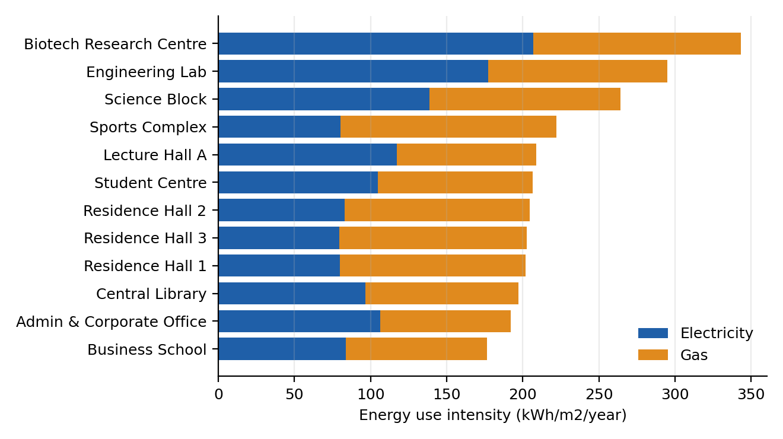
Figure 1. Energy use intensity by building (electricity and gas), 2025
Table 7. Summary by building type
Type | Buildings | Area (m²) | Electricity (MWh) | Gas (MWh) | EUI (kWh/m²) | Share of energy (%)
Academic | 5 | 41,800 | 3,955 | 4,508 | 202.5 | 32.4
Office | 1 | 6,500 | 692 | 556 | 192.1 | 4.8
Research | 3 | 37,500 | 6,479 | 4,753 | 299.5 | 43.0
Residential | 3 | 25,500 | 2,060 | 3,115 | 203.0 | 19.8

Table 8. Campus comparison
Campus | Buildings | Area (m²) | Electricity (MWh) | Gas (MWh) | Water (m³) | Solar (MWh) | tCO₂e
North | 6 | 58,000 | 6,987 | 6,646 | 153,028 | 179 | 4,017
South | 6 | 53,300 | 6,200 | 6,287 | 122,819 | 348 | 3,637

The two campuses are almost identical in intensity (North 235.0 kWh/m², South 234.3 kWh/m²), so campus-level averages hide the building-level differences that matter. South hosts most of the installed PV (348 MWh versus 179 MWh generated at North).

3.4 Temporal patterns
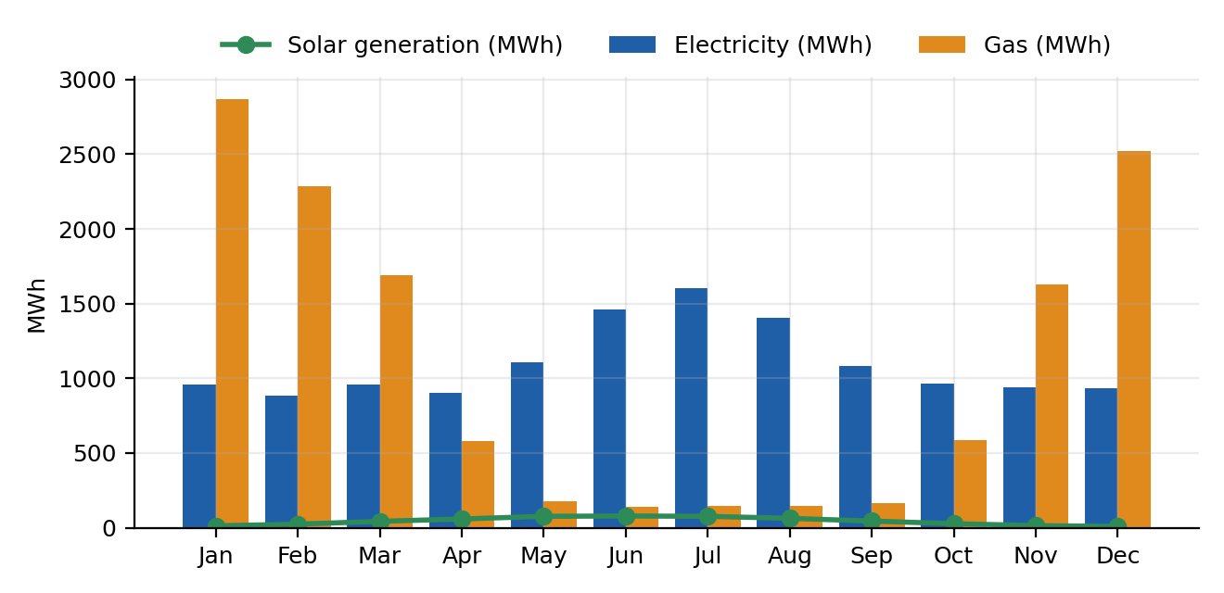
Figure 2. Monthly electricity, gas and solar generation
Gas follows the heating season, with winter months well above summer, while electricity rises in summer as cooling load increases (Appendix A). Average portfolio demand was 1,424 kW in term time and 1,756 kW during breaks, i.e. 23.3% higher during breaks. This is counter-intuitive and arises because the main break is the summer vacation, when cooling demand is highest; it also means that buildings are conditioned heavily while mostly empty, an important opportunity for set-back control.
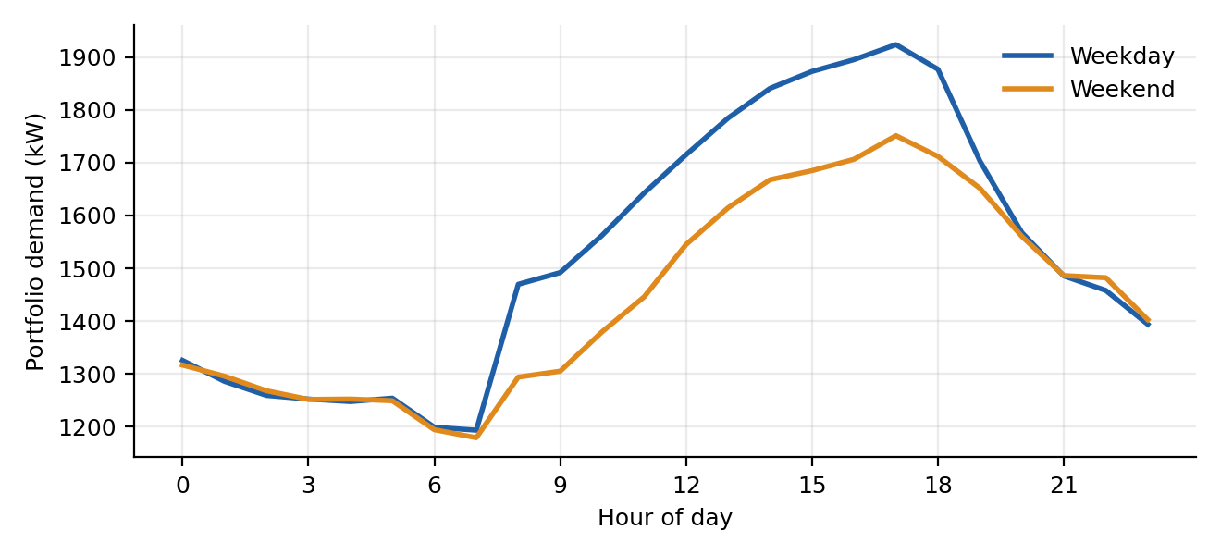
Figure 3. Average 24-hour portfolio demand profile, weekday versus weekend
The weekday profile reaches its low of 1,193 kW at 07:00 and its high of 1,923 kW at 17:00. Weekend demand averages 1,446 kW against 1,529 kW on weekdays, a gap of only 5.5%, which signals a high baseload that does not follow occupancy.

3.5 Waste and anomaly detection
The anomaly algorithm found 3 sustained electrical events totalling 24,186 kWh of excess consumption ($3,386 at the assumed tariff). The largest was a 6-day event at the Science Block.
Table 9. Detected electrical anomaly events
Building | Start | End | Hours | Excess (kWh) | Max excess (kW) | Cost ($)
Science Block | 2025-06-10 00:00 | 2025-06-15 23:00 | 144 | 13,047 | 120 | 1,827
Biotech Research Centre | 2025-10-02 00:00 | 2025-10-06 23:00 | 120 | 8,293 | 90 | 1,161
Sports Complex | 2025-02-14 00:00 | 2025-02-16 23:00 | 72 | 2,846 | 45 | 398

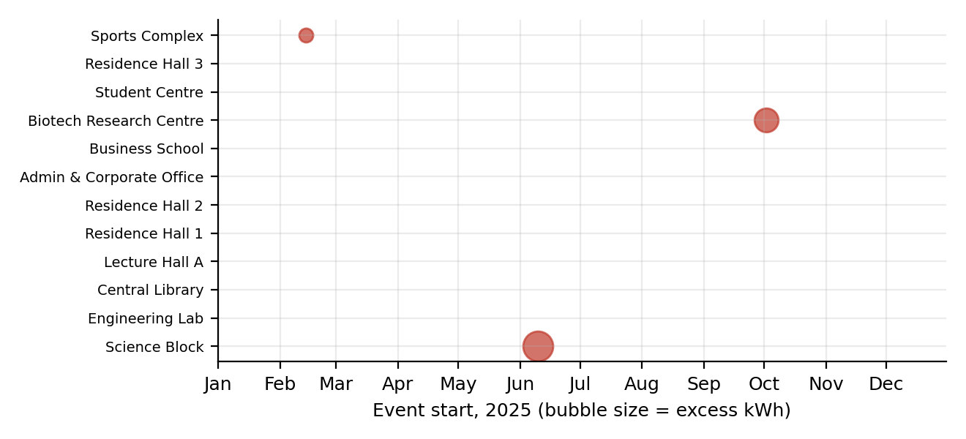
Figure 4. Anomaly events by building and date (bubble size proportional to excess energy)
A week-on-week check of gas data also revealed a rise of 13,791 kWh in Residence Hall 3 during the week beginning 3 November compared with the preceding week (about $621), consistent with a boiler or heating-control fault, and warranting site inspection.

3.6 After-hours and baseload waste
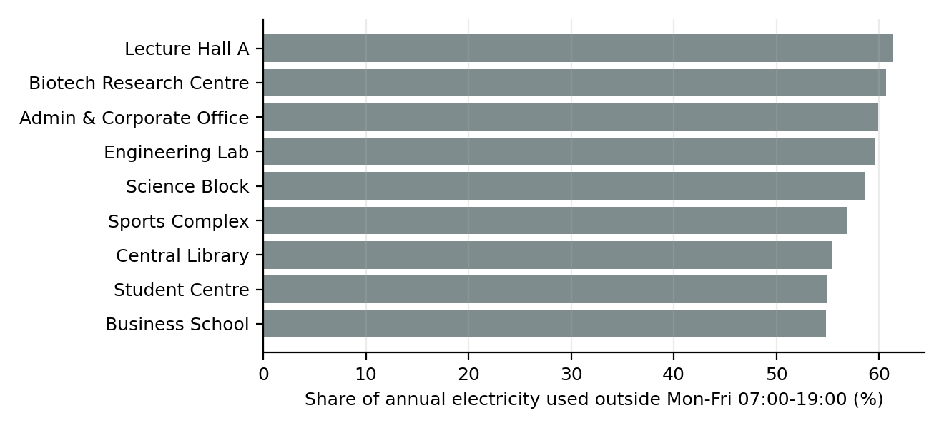
Figure 5. Share of electricity used outside Monday–Friday 07:00–19:00 (non-residential buildings)
After-hours consumption accounts for 55–61% of non-residential electricity, because a high baseload runs continuously. Night-time intensity (22:00–05:59) was compared with building-type peers. Two buildings exceeded their peer median by more than 15%.
Table 10. Night-time load screening (candidates above peer median)
Building | Type | Night load (kW) | W/m² | Excess vs peers (kW) | Excess (MWh/yr)
Lecture Hall A | Academic | 109.8 | 14.65 | 48.2 | 105.6
Biotech Research Centre | Research | 255.8 | 20.47 | 43.4 | 95.1

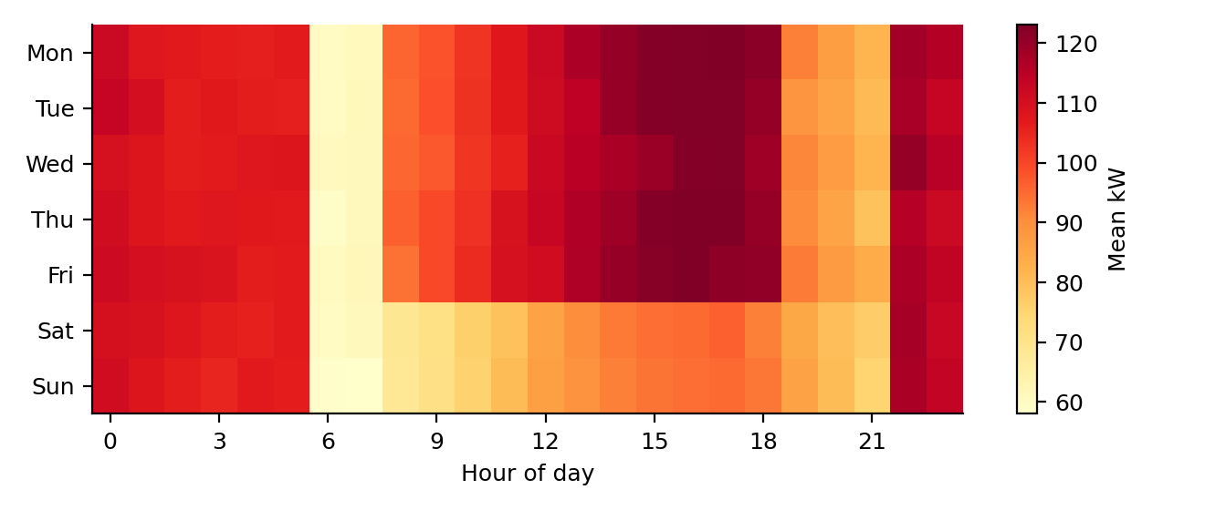
Figure 6. Lecture Hall A: mean demand by day of week and hour (night and weekend load is visible)
The Lecture Hall A heat map shows demand remaining high between 22:00 and 05:00 on every day, consistent with air-handling plant left running overnight. The Biotech Research Centre also shows a high night load, but laboratories often require continuous ventilation, so this is flagged for review rather than treated as confirmed waste. The combined screened excess is 201 MWh per year ($28,108).

3.7 Peak demand and forecasting
Table 11. Highest portfolio demand hours
Rank | Timestamp | Demand (kW)
1 | 2025-06-24 15:00 | 3,657
2 | 2025-07-11 16:00 | 3,577
3 | 2025-06-25 17:00 | 3,540
4 | 2025-06-30 14:00 | 3,532
5 | 2025-08-07 16:00 | 3,528
6 | 2025-06-25 16:00 | 3,487
7 | 2025-06-25 18:00 | 3,480
8 | 2025-07-29 16:00 | 3,478
9 | 2025-08-04 16:00 | 3,473
10 | 2025-07-23 17:00 | 3,433

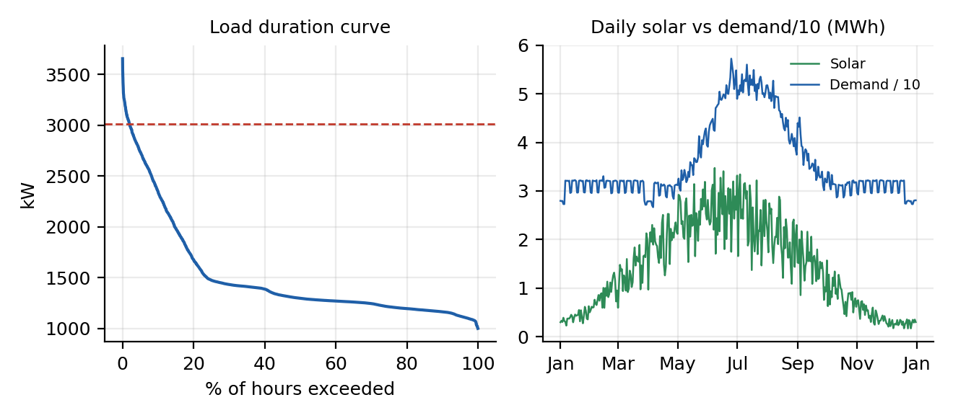
Figure 7. Load duration curve (left) and daily solar generation against scaled demand (right)
The ten highest hours all occurred during summer cooling conditions. Reducing each monthly peak by 5% (about 183 kW at the annual peak) would lower demand charges by about $16,716 per year under the assumed tariff, through pre-cooling, staggered plant start-up and temporary set-point relaxation.
Table 12. Forecast accuracy on held-out data (October–December 2025)
Model | MAE (kW) | RMSE (kW) | MAPE (%)
Seasonal naive (same hour, previous week) | 42.1 | 77.1 | 3.32
Gradient boosting (calendar + temperature + lag) | 22.9 | 30.1 | 1.78

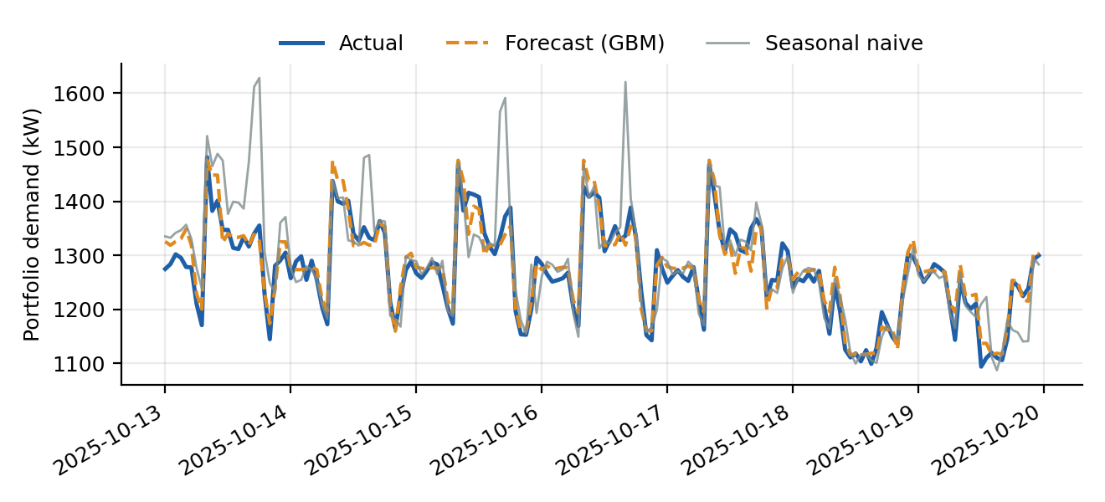
Figure 8. Actual versus forecast portfolio demand, 13–19 October 2025
The model was trained on 6,384 hours and tested on 2,208 hours. It reduces MAE by 46% and RMSE by 61% relative to the benchmark. For daily peak prediction, the model's MAPE was 1.20% (naive 4.30%), and 97.8% of days had a peak forecast within 5% of the actual peak. The test period covers autumn only; summer peaks were not in the test set, so accuracy on the highest summer peaks is not demonstrated here.

3.8 Occupancy and energy
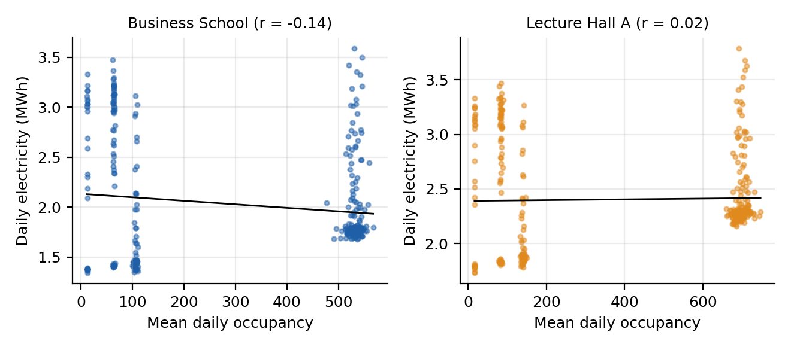
Figure 9. Daily electricity versus mean occupancy for two buildings
Table 13. Correlation and regression by building (daily data)
Building | Type | r (occupancy) | r (temperature) | R² (occ + cooling) | kW per person (OLS)
Science Block | Research | -0.22 | 0.80 | 0.94 | 0.07
Engineering Lab | Research | -0.23 | 0.81 | 0.98 | 0.07
Central Library | Academic | -0.15 | 0.80 | 0.97 | 0.03
Lecture Hall A | Academic | 0.02 | 0.75 | 0.98 | 0.03
Residence Hall 1 | Residential | 0.10 | 0.66 | 0.98 | 0.08
Residence Hall 2 | Residential | 0.18 | 0.62 | 0.98 | 0.08
Admin & Corporate Office | Office | -0.06 | 0.80 | 0.98 | 0.05
Business School | Academic | -0.14 | 0.79 | 0.98 | 0.03
Biotech Research Centre | Research | -0.27 | 0.82 | 0.96 | 0.07
Student Centre | Academic | -0.08 | 0.79 | 0.98 | 0.04
Residence Hall 3 | Residential | 0.09 | 0.66 | 0.98 | 0.08
Sports Complex | Academic | -0.19 | 0.77 | 0.96 | 0.04

Raw correlation between daily electricity and occupancy is weak (r between -0.27 and 0.18), because occupancy and weather move in opposite directions across the year: occupancy falls in the summer break while cooling load peaks. Once both predictors are included the models explain 94–98% of daily variation (R²). Occupancy-driven load is therefore modest relative to fixed baseload and weather-driven cooling, supporting a focus on schedules and set-points rather than occupant-count control alone. The "kW per person" column is the fitted occupancy coefficient converted to an hourly average; regression coefficients are indicative and are affected by collinearity.

3.9 Indoor environmental quality
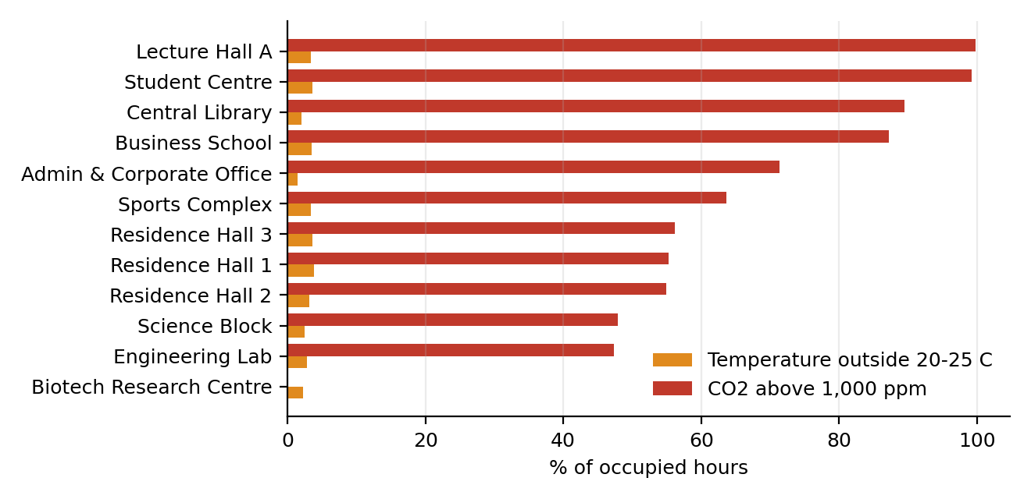
Figure 10. Share of occupied hours outside comfort and ventilation limits
Table 14. Indoor environmental quality, occupied hours only
Building | Mean °C | Temp outside 20–25 °C (%) | Mean CO₂ (ppm) | P95 CO₂ (ppm) | CO₂ > 1,000 ppm (%) | RH outside 30–60% (%)
Science Block | 22.1 | 2.4 | 918 | 1,192 | 47.9 | 1.2
Engineering Lab | 22.1 | 2.8 | 927 | 1,212 | 47.4 | 1.3
Central Library | 22.2 | 2.0 | 2,427 | 3,227 | 89.5 | 0.4
Lecture Hall A | 22.2 | 3.3 | 3,823 | 4,946 | 99.8 | 0.5
Residence Hall 1 | 21.9 | 3.8 | 1,015 | 1,403 | 55.2 | 0.7
Residence Hall 2 | 22.0 | 3.1 | 1,072 | 1,466 | 54.9 | 0.8
Admin & Corporate Office | 22.3 | 1.4 | 1,100 | 1,298 | 71.3 | 1.1
Business School | 22.3 | 3.5 | 2,326 | 3,030 | 87.2 | 0.7
Biotech Research Centre | 22.1 | 2.2 | 746 | 940 | 0.0 | 1.1
Student Centre | 22.3 | 3.6 | 2,717 | 3,537 | 99.2 | 0.9
Residence Hall 3 | 21.9 | 3.6 | 1,017 | 1,397 | 56.1 | 0.5
Sports Complex | 22.2 | 3.4 | 1,402 | 1,846 | 63.7 | 0.6

Temperature was within 20–25 °C for most occupied hours in all buildings (outside the range for 1.4–3.8% of hours). Ventilation is the main concern: Central Library, Lecture Hall A, Business School, Student Centre exceeded 1,000 ppm CO₂ in more than 80% of occupied hours. The occupied-hours filter used here is occupancy above 20% of capacity, so these are periods of meaningful use. High CO₂ alongside high baseload suggests that air is being conditioned continuously yet not delivered effectively where and when people are present, favouring demand-controlled ventilation.

3.10 Renewable generation
Table 15. Solar PV sites
Building | Capacity (kWp) | Generation (MWh) | Specific yield (kWh/kWp) | Share of building electricity (%)
Engineering Lab | 120 | 119.2 | 993 | 6.1
Residence Hall 1 | 60 | 59.6 | 994 | 8.8
Admin & Corporate Office | 200 | 198.8 | 994 | 28.7
Student Centre | 150 | 149.2 | 995 | 23.8

The four PV systems total 530 kWp and generated 527 MWh (average specific yield 994 kWh/kWp). Because every site consumes far more than it generates, 97.3% of output was used on site and export is negligible. Solar covered 3.9% of portfolio electricity and avoided about 205 tCO₂e, or 2.7% of estimated emissions. Self-consumption is not a constraint, so additional PV capacity would be fully absorbed under current loads.

3.11 Water
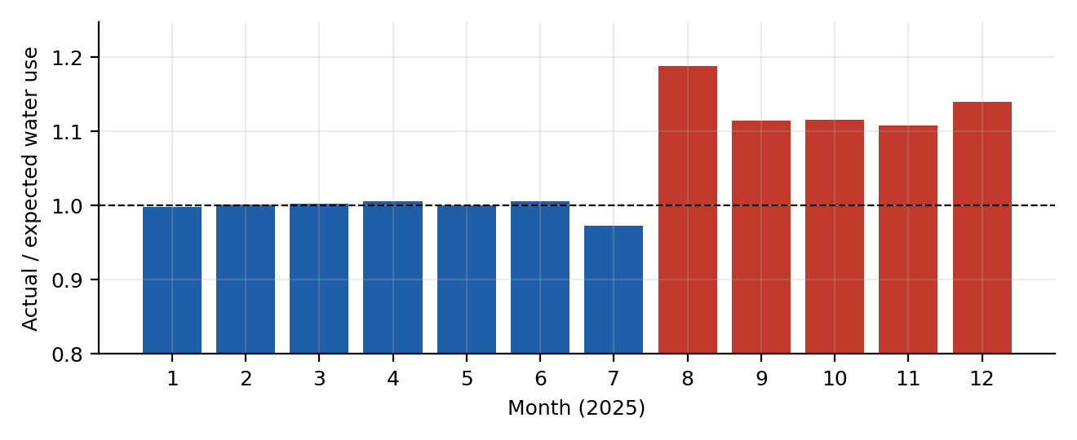
Figure 11. Residence Hall 2: actual versus expected water use relative to sister residences
Residence Hall 2 tracked its sister residences closely until early August (ratio ≈ 1.00 in January–June). From August the ratio rose to between 1.11 and 1.19, an unexplained increase of about 549 L/h (1,965 m³ to year end, $4,126). If unrepaired the loss is about 4,813 m³ per year ($10,107). July is lower because the residence was largely empty during the break, which the peer-ratio method accounts for.

4. Results and discussion

4.1 Cost and carbon profile
Table 16. Estimated annual utility cost (assumed tariffs)
Component | Cost ($) | Share (%)
Electricity energy | 1,846,142 | 55.2
Electricity demand charge | 334,329 | 10.0
Natural gas | 581,969 | 17.4
Water | 579,277 | 17.3
Total | 3,341,717 | 100.0

Total utility cost is estimated at $3,341,717 per year, 55% of it electricity energy. Emissions are 7,654 tCO₂e, of which electricity contributes 5,275 t and gas 2,380 t. The demand charge is computed on the portfolio coincident peak for illustration only; real billing is per meter and will differ.

4.2 Interpretation against objectives
- Visibility and benchmarking. A unified dataset exposes a 95% spread in EUI between the highest and lowest buildings, and within-type comparison singles out the Biotech Research Centre, whose EUI is well above the median of its research peers, ahead of the Sports Complex among academic buildings.
- Waste detection. Sustained faults (chiller, fan, pool heating, boiler) and a water leak were separable from normal variation, demonstrating the value of continuous baselining. The faults persisted for 3–6 days; with real-time alerting they could have been resolved within hours.
- Baseload dominates. Weekend demand is close to weekday demand and about 55–61% of non-residential electricity is used outside working hours. Scheduling and set-back are therefore likely to deliver more than occupancy-based control.
- Forecasting. Calendar and weather features give 1.78% MAPE for hourly demand, enough to support day-ahead peak management and renewable matching.
- Indoor quality versus energy. Comfort temperature targets were largely met, but ventilation performance was poor in several buildings. Energy reductions must not come from cutting ventilation; demand-controlled ventilation can improve both measures.

4.3 Platform implications
The findings translate directly into rules a monitoring platform should evaluate continuously and escalate to facilities teams:
Table 17. Suggested platform alert rules derived from the analysis
Rule | Trigger (configurable) | Example found in data
Sustained excess demand | Scaled residual > 6 and > 12% above baseline for ≥ 8 of 12 hours | Science Block chiller event
Night baseload drift | 22:00–05:59 W/m² > 15% above peer median | Lecture Hall A
Concealed leak | Water ratio to peers > 1.10 for 7 days | Residence Hall 2
Heating fault | Weekly gas > prior week + 25% at similar temperature | Residence Hall 3
Ventilation | CO₂ > 1,000 ppm for > 50% of occupied hours in a week | Lecture Hall A, Student Centre
Peak warning | Forecast demand > 98th percentile of history | > 3,010 kW
Data quality | Missing > 5% of hourly values in 24 h | Occupancy stream

Reliable alerting depends on data continuity. Edge gateways should buffer readings locally during network loss and back-fill on reconnection, data should travel over encrypted channels (for example TLS with device authentication), and ingestion and analytics services should run redundantly to meet availability targets.

5. Conclusion
This analysis of a simulated two-campus portfolio shows how unified telemetry supports sustainability management. The estate used 234.7 kWh/m² per year and emitted about 7,654 tCO₂e, with research buildings responsible for 43% of energy. Systematic problems were found: persistently high baseload (55–61% of non-residential electricity outside working hours), three sustained electrical faults, a gas excursion and a water leak. A simple machine-learning model forecast demand to within 1.78% MAPE, and solar supplied 3.9% of electricity at full self-consumption.
The main lesson is that operational control (schedules, fault response, leak repair, ventilation tuning) offers quicker and cheaper gains than capital works, and that continuous analytics are the mechanism that surfaces these opportunities. Because the data are synthetic, the specific magnitudes should not be quoted as real performance; the method, structure and workflow are what carry over.

6. Recommendations
Savings below are calculated from this dataset and the assumed tariffs and emission factors. Operational estimates assume that the identified excess can be removed; real outcomes require verification after implementation.
Table 18. Prioritised recommendations
# | Type | Action | Annual impact (this dataset) | Evidence
1 | Operational | Correct overnight air-handling and set-back schedules at Lecture Hall A; review Biotech Research Centre night ventilation with lab managers | Up to 201 MWh, $28,108, 80 tCO₂e | Sec. 3.6
2 | Operational | Repair concealed leak in Residence Hall 2 and add continuous night-flow alarms | 4,813 m³, $10,107 per year if unrepaired | Sec. 3.11
3 | Operational | Real-time fault alerts for chiller, fans, pool and boiler plant | 24,186 kWh and 13,791 kWh gas avoided per comparable year ($4,007) | Sec. 3.5
4 | Operational | Peak management: pre-cooling, staggered start-up, forecast-driven alerts | ~183 kW lower peak, $16,716 demand charge | Sec. 3.7
5 | Operational | Demand-controlled ventilation and CO₂ monitoring in Lecture Hall A, Student Centre, Central Library, Business School | Comfort and health benefit; energy effect to be measured | Sec. 3.9
6 | Capital | Retrofit feasibility study for the Biotech Research Centre (heat recovery, fume-hood and VAV controls, chiller upgrades), then the Sports Complex | Largest gaps to peer median, Table 19 | Sec. 3.3, 6
7 | Capital | Expand rooftop PV; current output is fully self-consumed | Each +100 kWp ≈ 99 MWh and ≈ 40 tCO₂e (using this site yield) | Sec. 3.10

Combined operational measures 1–4 total about $58,937 per year (about 1.8% of estimated utility cost). These figures are not additive with certainty because some effects overlap.
Table 19. Capital priority by energy gap to building-type peer median (top four)
Building | Type | EUI | Peer median EUI | Gap (MWh/yr) | Gap (tCO₂e/yr, at mixed factor)
Biotech Research Centre | Research | 343.3 | 294.9 | 605 | 190
Sports Complex | Academic | 222.3 | 206.5 | 165 | 43
Residence Hall 2 | Residential | 204.8 | 202.5 | 18 | 5
Lecture Hall A | Academic | 208.7 | 206.5 | 16 | 5

Capital costs and payback periods were not part of the data, so no financial return is calculated; the table ranks where an investment study should start. Research buildings are compared only with other research buildings.

6.1 Implementation roadmap
- 0–3 months: deploy fault and leak alerts, fix schedules at Lecture Hall A, inspect Residence Hall 2 and 3, validate sensor data quality.
- 3–9 months: commission demand-controlled ventilation, begin peak-warning notifications using the forecast model, review laboratory ventilation.
- 9–24 months: complete retrofit feasibility studies and PV expansion business cases; automate sustainability and compliance reporting from the platform.

7. Limitations
- The dataset is synthetic. Patterns such as faults, leaks and baseloads were designed into the simulation; detection performance here is not evidence of performance on real telemetry, where noise, drift and sensor faults are less cleanly separated.
- Weather, occupancy and tariffs are simulated or assumed. Emission factors and prices should be replaced with local, current values.
- Only one year was analysed. Forecasts were tested on October–December and not on summer peaks; multi-year data would improve baselines.
- Demand charges were applied to the portfolio coincident peak rather than per-meter billing.
- Night-load excess compares buildings with peers of the same type and does not prove waste; laboratories in particular may need continuous ventilation.
- Savings estimates assume removal of identified excess and are not net of implementation cost. No capital cost data were available.
- IEQ thresholds (20–25 °C, 1,000 ppm CO₂, 30–60 %RH) are screening values and should follow local standards and policy.

References
ASHRAE (2023). ANSI/ASHRAE Standard 55: Thermal Environmental Conditions for Human Occupancy. Atlanta: ASHRAE.
ASHRAE (2022). ANSI/ASHRAE Standard 62.1: Ventilation and Acceptable Indoor Air Quality. Atlanta: ASHRAE.
Friedman, J. H. (2001). Greedy function approximation: a gradient boosting machine. Annals of Statistics, 29(5), 1189–1232.
Hyndman, R. J., & Athanasopoulos, G. (2021). Forecasting: Principles and Practice (3rd ed.). OTexts.
ISO (2018). ISO 50001: Energy management systems — Requirements with guidance for use. Geneva: ISO.
ISO (2014). ISO 50006: Energy management systems — Measuring energy performance using energy baselines and energy performance indicators. Geneva: ISO.
Leys, C., Ley, C., Klein, O., Bernard, P., & Licata, L. (2013). Detecting outliers: do not use standard deviation around the mean, use absolute deviation around the median. Journal of Experimental Social Psychology, 49(4), 764–766.
World Resources Institute & World Business Council for Sustainable Development. The Greenhouse Gas Protocol: A Corporate Accounting and Reporting Standard (revised edition).

Appendix A. Monthly portfolio summary
Table 20. Monthly totals
Month | Electricity (MWh) | Gas (MWh) | Water (m³) | Solar (MWh) | Peak kW | tCO₂e
Jan | 958 | 2,871 | 24,142 | 12.6 | 1,510 | 912
Feb | 882 | 2,283 | 23,003 | 24.0 | 1,501 | 773
Mar | 957 | 1,689 | 24,187 | 42.7 | 1,498 | 693
Apr | 901 | 579 | 22,968 | 58.7 | 1,549 | 467
May | 1,106 | 174 | 25,442 | 76.4 | 2,989 | 474
Jun | 1,461 | 142 | 24,650 | 78.7 | 3,657 | 611
Jul | 1,601 | 147 | 16,365 | 76.3 | 3,577 | 668
Aug | 1,403 | 147 | 16,665 | 63.0 | 3,528 | 588
Sep | 1,081 | 164 | 25,117 | 44.4 | 3,077 | 462
Oct | 966 | 586 | 25,967 | 27.2 | 1,973 | 494
Nov | 938 | 1,626 | 24,845 | 14.2 | 1,504 | 675
Dec | 933 | 2,524 | 22,493 | 8.6 | 1,498 | 838

Rubrics for Calculation
Criteria | Excellent (5 Marks) | Good (3 Marks) | Satisfactory (2 Marks) | Needs Improvement (1 Mark)
Problem Understanding (30%) | Clearly explains the problem, objectives, and scope with complete understanding. | Explains the problem with minor omissions. | Basic understanding with limited explanation. | Poor understanding; objectives and scope are unclear or missing.
Stakeholder & Challenge Analysis (25%) | Identifies all stakeholders, their roles, and challenges with clear analysis. | Identifies most stakeholders and challenges with adequate analysis. | Identifies only a few stakeholders or challenges. | Stakeholders and system analysis are incomplete or inaccurate.
Current System Analysis (20%) | Thoroughly analyzes the existing system, strengths, weaknesses, and identifies all gaps. | Good analysis with most strengths and weaknesses identified. | Limited analysis with partial identification of issues. | Proposed solution is unclear or inappropriate; requirements are largely missing.
Proposed Software Solution & Software Engineering Principles (15%) | Proposes an innovative, feasible solution applying appropriate software engineering principles (modularity, scalability, maintainability, security, etc.). | Suitable solution with good application of software engineering principles. | Basic solution with limited application of software engineering principles. | Methodology is inappropriate, poorly justified, or not discussed.
Methodology/ Framework Justification (10%) | Selects the most suitable SDLC/model/framew ork and provides strong technical justification. | Suitable methodology selected with adequate justification. | Methodology selected but justification is weak. | Outcomes, limitations, or future enhancements are missing; report lacks organization and clarity.

Criteria | Mark
Problem Understanding (30%) | /5
Stakeholder & Challenge Analysis (25%) | /5
Current System Analysis (20%) | /5
Proposed Software Solution & Software Engineering Principles (15%) | /5
Methodology/ Framework Justification (10%) | /5
TOTAL | /25

